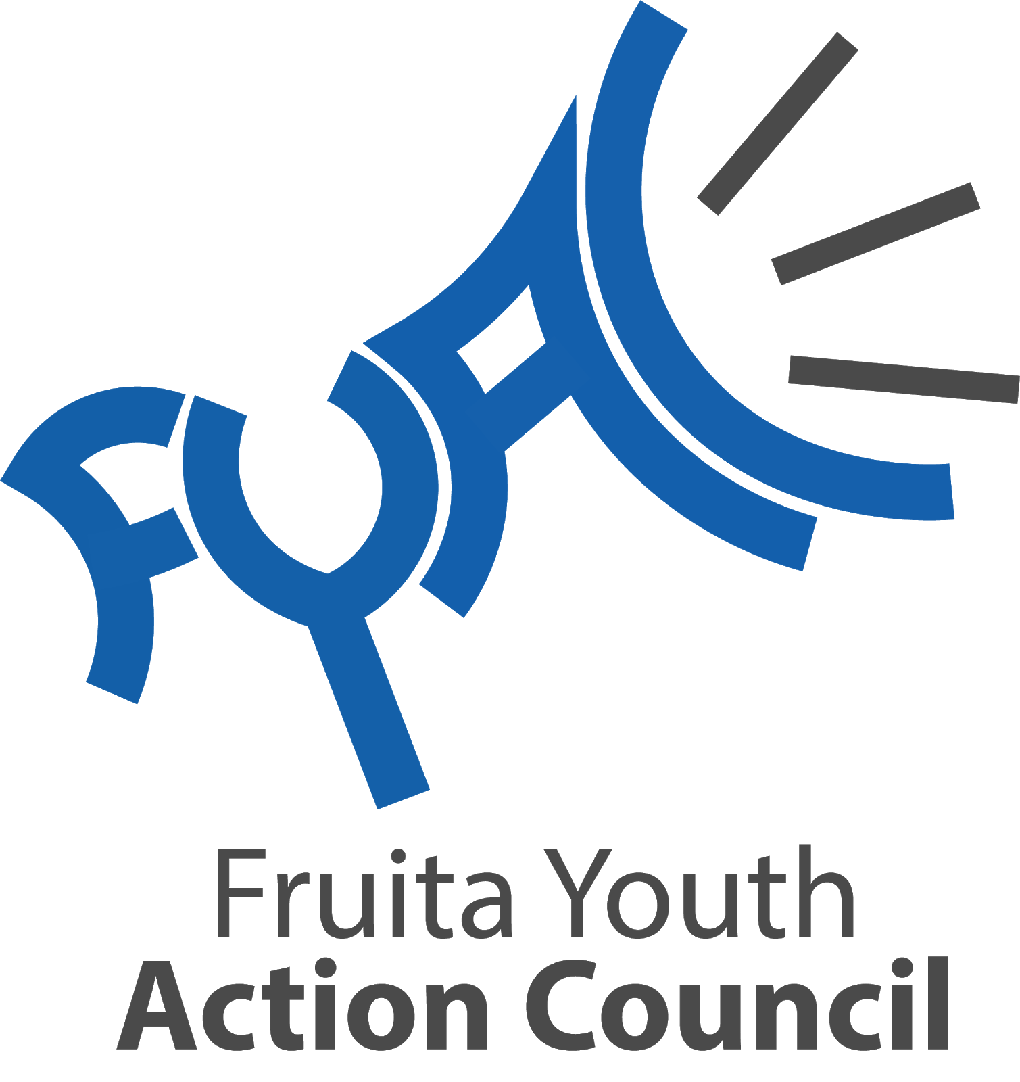

Fruita Youth Action Council 2024-2025 Application

FYAC is a group of students working collaboratively with peers and community organizations to provide meaningful input on youth related issues, programs, and the promotion of health. We want to have diverse and unique perspectives; students from all backgrounds are encouraged to apply!

Fully complete application before the deadline of April 1st. Interviews will be conducted mid-April (TBD).

To be considered for the 2024-2025 term, you must be in 6th through 12th grade for this upcoming school year. Current 5th graders for the 20230-2024 school year are eligible to apply.

FYAC meets on the second Monday of every month at 6:30-8:00 pm. Regular attendance to these meetings is required.

There is an online form at www.fruita.org/fyac. This is an alternative to those who do not have access to a computer/internet or prefer written methods. Please print all responses legibly. If additional space is needed for responses, additional pages are allowed to be attached in an organized fashion.

To submit a physical application, drop off completed applications to Miranda Carrithers at the Fruita Community Center:

324 N. Coulson St.
Fruita CO 81521
(970) 858-0360 ext. 6407

General Information

Name (first & last)
Street address
City Zip code
Phone number (cell)
Other phone (not required) Email Date of Birth (mm-dd-yyyy)
Grade Starting in fall of 2024
What school will you attend in fall of 2024 Gender (not required)
Parent/Guardian Name Parent/Guardian phone number (cell) Parent/Guardian phone number (specify work or home)

Why are you interested in being a member of Fruita Youth Action Council (FYAC)?

Explain what a "strong youth voice" means to you and the importance of youth collaboration in community planning, events, initiatives, and programs.

What unique perspectives or attributes can you bring to FYAC? (i.e. accomplishments, travels, hobbies, leadership, independence, diverse background, activism, art/graphic design)

List any extracurricular activities are you involved in (i.e. sports, clubs)

List with a short description any volunteer or work experience

Provide any additional information or references you believe are pertinent in consideration of your application

Additional Information

Are you a part of your school’s SOS team? (circle) Yes No

Do you have the time and availability to commit to attending monthly meetings, FYAC projects, and occasional special events? (circle)

Yes No

Are you committed to serving a full 1 year term? (circle) Yes No

Do you have parent/guardian permission for this application and to be a member of FYAC? (circle)

Yes No

Do you certify that all information provided in this application is true and filled out as completely as possible? (circle)

Yes No

